**UNHM MATH 422 Final Exam** NAME______________________________________________

**SPRING 2023**  Date_____________________________________

**PLEASE REMEMBER:**  Show your reasoning and/or math work in every problem. Some questions have more than one part. Make sure you answer every part of the question that was asked. You are being asked to calculate some things and interpret others.

***Base Score (47 points)***: Did you *attempt* to answer every question? YES NO

**Consultation (5 points):** Did you meet with Prof Rudis on Thursday to discuss preparation for this exam? YES NO

**1. (4 pts)**

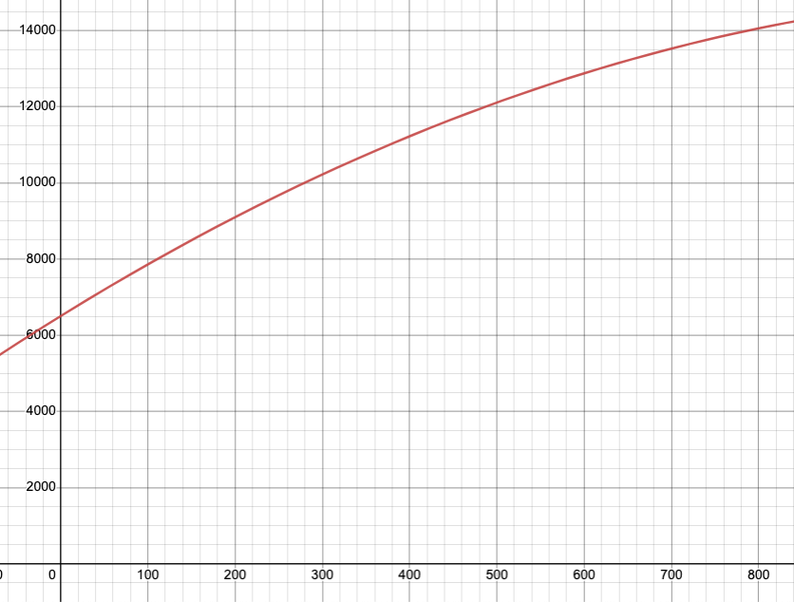The total cost *C(x)*, in dollars, to produce *x* items is given by the function graphed below.

Cost (C)

Quantity (x)

Find the average cost per item (the average rate of change) when increasing production from **120 units** to **480 units**.

Show your work here:

UNHM MATH 422 Exam #1 Page 2/6 Initials_____________

**2. (4 pts)**

Given a table of x and y values, find the average rate of change on an interval. Suppose f(x) is defined for all x in $0≤x≤30$ and is “well behaved”. A table of values was created here:

|  |  |
| --- | --- |
| x | y |
| 0 | 12 |
| 4 | 32.8 |
| 8 | 47.2 |
| 12 | 55.2 |
| 16 | 56.8 |
| 20 | 52 |
| 24 | 40.8 |
| 28 | 23.2 |

What is the average change in f(x) in $4≤x≤20$? That is, between x = 4 and x = 20  
  
Show your work here:

**3. (4 pts)** Here we have a partial graph of a function f(x) = y

a. What is f(4)? _____________

b. What is $m=\frac{Δy}{Δx}$? ______________

c. When $∆x$ = 6, what is $∆y$?

ie (0,0) to (6, ?? ) might help…

y

_________________________

d. What is the equation of the graph?

[ Use y = mx + b, where b = 0]

_________________________

x

UNHM MATH 422 Exam #1 Page 3/6 Initials______________

**4. (4 pts)**

Suppose quantity (*x*) of a product when the price is *y* dollars is given by the demand equation $y=700-2x$   , and the supply equation $y=200+3x$  . You are asked to graph these two equations. Create two tables of (*x,y*) values and plot the lines here. Then answer the questions:

*y*

*Price*

*x (Quantity)*

|  |  |
| --- | --- |
| x | y=700 - 2x |
| 0 |  |
| 40 |  |
| 80 |  |
|  |  |

|  |  |
| --- | --- |
| x | y=200+3x |
| 0 |  |
| 40 |  |
| 80 |  |
|  |  |

a) Sketch the supply and demand lines (do your best to locate the points and make straight lines)

b) Find the equilibrium price and quantity.

UNHM MATH 422 Exam #1 Page 4/6 Initials______________

**5. (4 pts)**

You deposit $3000 in an account that earns interest at the rate of 2.8% compounded monthly. How much will be in the account in 18 years? Use $A=P⋅{(1+\frac{r}{k})}^{k⋅t}$ where *k* is the number of compounding periods in a year

**6. (4 pts)** Fill in the table with missing values and graph the function $y=\sqrt{x}$

|  |  |
| --- | --- |
| x | y |
| 0 |  |
| 1 |  |
| 4 |  |
|  | 3 |
|  | 5 |

**7. (4 pts)**

What is the slope of the line through the point (4,16) and (4.01, 16.0801) on the curve $y=x^{2}$?

Use that answer to estimate the slope of the tangent line at (4, 16)

**8. (4 pts)**

The total cost to produce x items is given by $C\left(x\right)=-0.03x^{2}+18x+135$ and the marginal cost equation is $C^{'}\left(x\right)=-0.06x+18$. If 150 items are being made, how much would it cost to make one more?

UNHM MATH 422 Exam #1 Page 5/6 Initials______________

**9. (4 pts)**

The graph of $a recall curve$ is given. It represents how much is recalled after x days. The tangent line at x = 4 is shown and points are labeled. **What is the rate of change of y with respect to x at day 4?**

$\frac{dy}{dx} at x=4$ is:

y=f(x)

Use this number to estimate y when x = 5:

__________________________

**10. (4 pts)**

Having given a test to two classes, the grades were as follows:

|  |  |  |  |  |
| --- | --- | --- | --- | --- |
|  | A | B | C | Total |
| Morning | 12 | 8 | 16 | 36 |
| Afternoon | 9 | 15 | 6 | 30 |
| Total | 21 | 23 | 21 | 66 |

If one student is selected at random, what is the probability that they got a C ?

UNHM MATH 422 Exam #1 Page 6/6 Initials_____________

**11. (4 pts)**

The price of a dishwasher is given by $price=y=775-2x$ where x is units made/sold. The marginal revenue is $R^{'}\left(x\right)=775-4x$

1. R(x) = price * quantity. Write R(x) __________________________________
2. What is the marginal revenue to sell one more dishwasher if 115 dishwashers are being made/sold?

**12. (4 pts)**

Calculate marginal revenue (R’(x)) and marginal cost (C’(x)) with the formulas given and the values of x given. Use this to determine at what production level would profit be maximized?

|  |  |  |
| --- | --- | --- |
| x | $$R^{'}\left(x\right)=820-0.4x$$ | $$C^{'}\left(x\right)=500+1.2x$$ |
| 120 |  |  |
| 160 |  |  |
| 200 |  |  |
| 240 |  |  |

**Exam Scoring Sheet**

Base Score – Did you attempt EVERY question? _______________ (52 points possible)

Question #1 ______________ (4 points possible)

Question #2 ______________ (4 points possible)

Question #3 ______________ (4 points possible)

Question #4 ______________ (4 points possible)

Question #5 ______________ (4 points possible)

Question #6 ______________ (4 points possible)

Question #7 ______________ (4 points possible)

Question #8 ______________ (4 points possible)

Question #9 ______________ (4 points possible)

Question #10 ______________ (4 points possible)

Question #11 ______________ (4 points possible)

Question #12 ______________ (4 points possible)

TOTAL: _______________